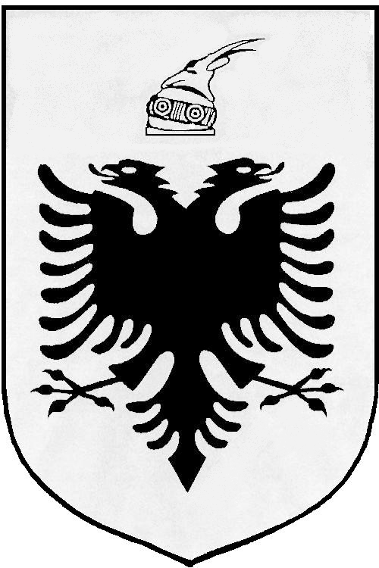
MISIONI I PËRHERSHËM I  REPUBLIKËS SË SHQIPËRISË  GJENEVË | PERMANENT MISSION OF  THE REPUBLIC OF ALBANIA  GENEVA

Universal Periodic Review

27th
Session

(1 – 12 May 2017)

Albania Intervention on the Third Cycle of the UPR of Finland

Geneva, 3 May 2017

-Check against delivery-

Mr. President,

Albania would like to welcome and congratulate the Finnish delegation on presenting their UPR Report today before the Human Rights Council.

It is remarkable the progress made in the promotion of human rights since the Second Universal Periodic Review of Finland, in particular the establishment of the Second National Action Plan on Fundamental and Human Rights with a focus on fundamental and human rights education, equality and non-discrimination.
Albania also welcomes major structural reforms in social welfare and health care in order to strengthen the legal protection of individuals.

While encouraging the Government of Finland to further strengthening its national efforts and human rights mechanisms, Albania would like to make the following recommendations:

- Consider to improve its legal and institutional frameworks for protection against discrimination by ensuring the same level of protection for all grounds of discrimination.

- Continue its efforts in the field of combating and eliminating discrimination on the grounds of sexual orientation and gender identity, inter alia, by implementing comprehensive legislative reform that guarantees equal protection from discrimination on all grounds.

In conclusion, Albania would like to wish to the delegation of Finland, a very successful review.

Thank you!

